Sistemas Informáticos (Computer Systems)
Unit 03. Fundamental of operating systems



Authors: Sergi García, Alfredo Oltra
Updated September 2022

Licencia

Reconocimiento - No comercial - CompartirIgual (BY-NC-SA): No se permite un uso comercial de la obra original ni de las posibles obras derivadas, la distribución de las cuales se ha de hacer con una licencia igual a la que regula la obra original.

Nomenclatura
A lo largo de este tema se utilizarán diferentes símbolos para distinguir elementos importantes dentro del contenido. Estos símbolos son:

📖 Important

❕ Attention

💬 Interesting
INDEX
Introduction 3
History 3
Operating system classification 4
Number of users 4
Number of processors 4
Number of tasks 4
Operating systems classification 4
Most popular operating systems 5
Operating systems function 5
Process management 5
What is a process? 5
Process states 6
Short term scheduler algorithms 6
How to solve a “Scheduling algorithms” exercises? 8
Memory management 8
Input / Output management 9
Ways to manage I/O 9
Techniques to increment I/O performance 9
File system management 10
File system structure 10
File system attributes 10
Absolute and relative paths 11
Most popular file systems features 11
Additional material 12
Bibliography 12
UD03. Fundamental of operating systems

Introduction
An operating system is the basic software to manage the computer. It manages all hardware resources, hiding complexity to the final user, who see a graphical interface. Also, it is responsible to run applications. We can say that operating system is between hardware and applications.
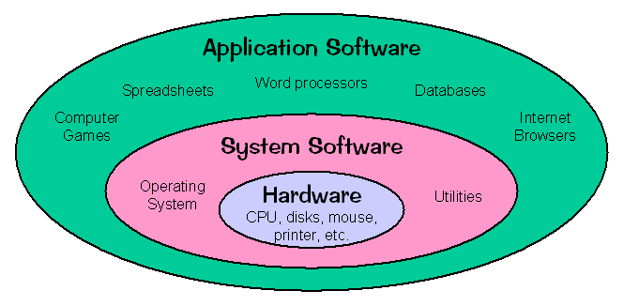

History
We can summarize the history of Operating Systems (OS) in these points:
- First computers didn’t have an operating system and programmers interacted with them modifying the hardware.
- The operating system concept appear in 50s, doing basic task like running a program and when it finishes, run another program.
- In 60s, main concepts of operating systems are developed, like multi-user, multi-task, multi-processor and real time operating systems. At late 60s Unix appear.
- In 70s, computers arrive to a lot of new users (instead of only governmental agencies and big corporations) and tools like C programming language were born (Unix was re-written in C language).
- In 80s, computers try to be more human-friendly, and it starts the graphical interface development.
- In 90s, appeared operating systems like Linux or Windows. They are the most used nowadays.
- In the 2000s appear other popular operating systems like Android or IOS.

Operating system classification
We can classify operating systems by several parameters. Sometimes, an operating system doesn’t fit exactly in these classifications, but they are the most practical ways to classify them.

Number of users
- Mono-user: only one user can work with one computer at the same time.
- Multi-user: several users can work with one computer at the same time.

Number of processors
- Mono-processor: operating system only supports one processor.
- Multi-processor: operating system supports more than one processor.
  - Symmetric: process are distributed through all processor.
  - Asymmetric: one or several processors are in charge of system process and one or several processors are in charge of user process.

Number of tasks
- Mono-task: operating system can manage only one task.
- Multi-task: operating system can manage several tasks at the same time.

💬 Interesting: A mono-processor operating system could be multi-task? Yes, it could. One processor only can do an operation at the same time, but there are techniques to change quickly between tasks, and it has the effect that we are running several tasks at the same time. That technique is used for most popular operating systems.

Operating systems classification

Operating systems | Number of users | Number of tasks | Number of processors
MS-DOS | Mono | Mono | Mono
Windows 9x, Me | Mono | Multi | Mono
Windows XP/Vista/7/8/10/11 | Mono/Multi | Multi | Multi
UNIX, Linux, Windows NT, Windows Server | Multi | Multi | Multi

Most popular operating systems
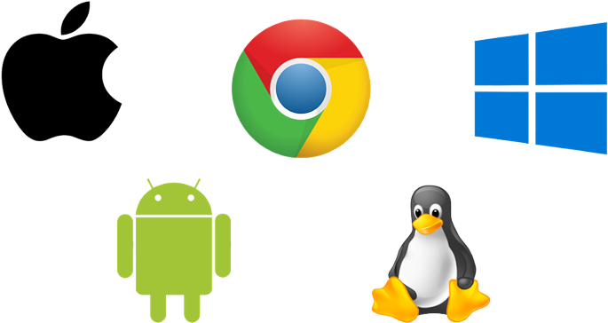
In this point we are going to talk about most popular operating systems. Several of them are free software (you can obtain source code and modify it, and usually you don’t have to pay for them), but others are privative software (source code is secret, and you have to pay for them).
Nowadays, the most popular operating systems are:
- Linux: very popular at server and desktop computers. It is free software.
- Windows systems: they are popular at server and desktop computers. They are privative software.
- Mac OsX: for use in Mac computers, based on BSD. It is privative software.
- Android: for use in mobile devices, usually mobile phones and tablets. It is free software.
- Apple IOS: for use in Apple mobile devices, often iPhone and iPad. It is privative software.

Operating systems function
We are going to describe the main functions of an operating system.
- Process management: the operating system manage processes in order to decide which of them uses the CPU.
- Memory management: the operating system manages memory to decide organization and limits for each process.
- Input / Output devices management: the operating system manages I/O operations.
- File system management: the operating system manages how data is organized by a file system.
On next points, those functions will be detailed.

Process management
Process management is a problem of multi-task systems. Mono-task system doesn’t have that problem because a process always uses all the CPU.

What is a process?
A process is a program running that needs to be allocated in memory, and it needs to use CPU. Also, it can use other resources like I/O devices. A good example is the difference between a recipe (the program) and cook that recipe (the process).

❕ Attention: a process is not a program. A program is a set of executable, data, resources, etc. but a process is a running program. Usually when you run a program, it only creates one process, but some programs create more than one process.

Process states
A process has different states and transitions between them, as you can see in this figure:
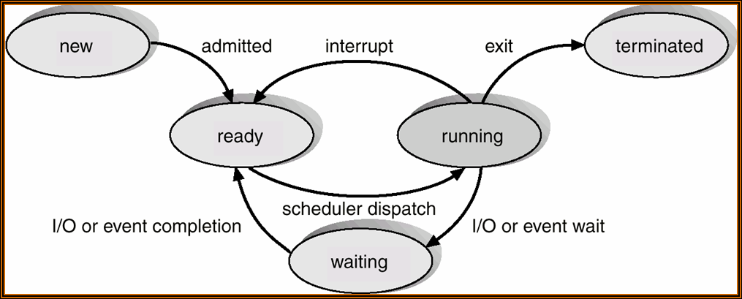
The state of a process defines what is its situation currently. We are going to define process states and their transitions.
- New: when a program is run, there is a system program call “long term scheduler” that decides if a process is admitted or not (It usually depends on memory available, number of processes not too high, etc.).
  - New → Ready: when “long term scheduler” accepts the process, it goes to ready state.
- Ready: the process has all the resources that need to use the CPU. But it isn’t using the CPU. It has to wait to be selected by a system program called “short term scheduler”.
  - Ready → Running: when “short term scheduler” select our process, it goes to running state.
- Running: the process is using CPU and doing its operations.
  - Running → Waiting: process needs a I/O operation to continue and voluntary leaves CPU.
  - Running → Ready: process is OK to run, but “short term scheduler” decides it has to leave CPU.
  - Running → Terminated: process did its last operation and leaves CPU.
- Terminated: the process has ended its execution.
- Waiting: the process is waiting for a I/O operation (for example, waiting for a data read from a hard disk).
  - Waiting → Ready: I/O operation has finished, and the process is ready to use CPU.

Short term scheduler algorithms
Short term scheduler has to decide which process is using CPU. If a computer has only one processor, only one process could be using it in a time instant.
There are several algorithms to decide which process uses CPU and try to do it as equitable as possible. Those algorithms could be modified, setting priority (making several processes more important than others).

📖 Important: we are going to study several “Short term scheduler” algorithms for educational purposes, but modern computers use “Round robin” algorithm and modifications of it.
FIFO (First in, First Out):
- It is like a supermarket queue. The first arrives, the first served.
- Example of use:
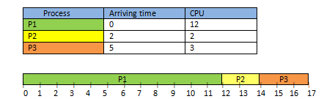
Shortest Remaining time First
- The process who needs less CPU time is served. In this algorithm, we suppose an incoming process can expel a running process.
  - This algorithm is not viable for two reasons:
    - We can’t predict the duration of the process.
    - It can produce starving (if constantly are arriving short processes to CPU, a long process will never use CPU)
- Example of use:
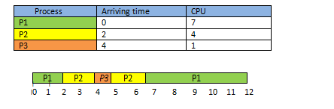
Round Robin:
- It uses a concept called quantum. Quantum is the number of CPU instant that can be done if a process is waiting for use CPU. It is equitable, and it (and modifications of it) are the most used in real operating systems.
- Example to understand it:
  - It is like if you have to rent a football pitch. If quantum is 2, you can rent it for two hours. If other users are waiting, when you finish they can't rent the pitch for two hours, but if nobody is waiting, you can rent it for 2 hours again.
    - If a team leaves before using 2 hours (they only play 1 hour) the pitch could be rented again.
- Example of use:
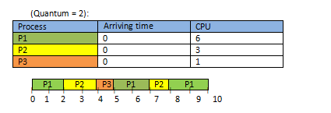
❕ Attention: actually in a real computer, process can’t arrive at the same time. But if in a theoretical exercise several processes arrive at the same time (like the example), you can decide the order they go to the processor.

How to solve a “Scheduling algorithms” exercises?
In our subject (Computer Systems) there are exercises in order to check your knowledge of scheduling algorithms. Those exercises are solved just as a computer does: understanding the algorithm and following it. In general, understand these algorithms is very easy, but the “Round Robin” algorithm is a little more complicated.

Memory management
Memory management is a problem of multi-task systems. Mono-task system doesn’t have that issue because a process always uses all the memory available.
Memory is a highly demanded element: there is little quantity and all the processes want a lot. The management of how to distribute it has been modified since the appearance of the first operating systems, according to the amount of memory available and the number of concurrent processes, which is increasing.
Usually, a portion of RAM is called a “page”. The size of the page depends on the operating system implementation.
Memory management is the part of the operating system that solves those problems:
- Protection problem: a process should not invade other process memory space. To solve this problem, the operating system detects if a process is using more than the provided space and if it does, it raises an error.
- Re-allocation problem: when a program is compiled, it doesn’t know in which memory positions it is going to run. It depends on memory state, processes running, etc
  - To solve this problem, a program always thinks it has a “virtual memory space”, starting in address 0 with all memory available.
  - When a program is running, the operating system transforms the addresses of its virtual space to virtual addresses that the operating system uses internally. Virtual addresses are explained in the next point.
- Assignation problem: when a process finish, it leaves from CPU and free the memory space that it occupied, creating gaps in memory. Therefore, it is possible that there was plenty of space in memory for a new process, but maybe that space is not continuous.
  - The operating systems solve this problem by this way: they use virtual addresses, which instead of being one-dimensional (3, 56, 2340, etc.) are bidimensional ((23,12567) (656,12300), (45,4)):
    - The first field indicates the direction of Initial memory (of the real memory).
    - The second field indicates the offset with respect to the first.
  - With this trick, the program calls, for example, the virtual direction (452,45), and the Operating System convert it in the real direction 497.
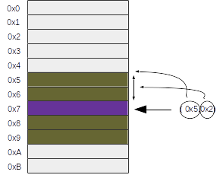
  - Graphical example with (5,2), pointing to 7.

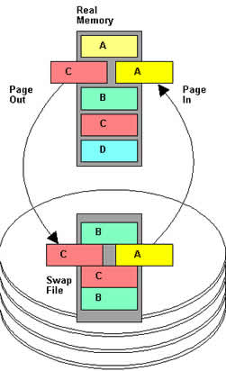
- Low memory available problem (Swapping): when we need to use more memory than memory physically available, we can use a technique called swapping.
  - This technique uses other devices (like Hard disk) that are slower than RAM memory to allocate less used pages. When a page allocated in the hard disk is required, a swap is done between a RAM page (frequently, less used of them) and the hard disk page.
  - A very important thing to remember is that a process only can be executed if it is located in memory RAM. Never in hard disk
  - For performance reasons, when we request information that is stored in a hard disk, it is swapped with less used page of memory and then the program can read it. The information is never accessed directly from hard disk, as if hard disk was an extension of RAM memory.

Input / Output management

Ways to manage I/O
Mainly, there are 3 ways to manage I/O:
- Programmed I/O: each user process has to check (using CPU time) if a I/O operation is performed. When an I/O operation is performed, it reads results. This way only works for mono-task systems and is very inefficient.
- Interruptions: operating system detects when a I/O operation is done and notifies it to the running process and only uses CPU time reading the result. When a process is waiting for I/O isn’t using CPU time (Is in state “Waiting”).
- DMA (Direct Memory Access): It is a technique usually combined with interruptions. For several I/O operations (like hard disk to RAM operations) CPU doesn’t do the operation, it is done by other chips, reducing the CPU workload.

Techniques to increment I/O performance
Usually, I/O devices are slower than CPU. To reduce this problem, we usually use caches. For example, if an operating system wants to write a data in a hard disk, it doesn’t wait to hard disk to finish the operation. The operating system writes the information in the cache and when it is done, the computer thinks “data has been written”, but it isn’t really written since the hardware component has done the process.
💬 Interesting: this performance technique is one of the reasons to avoid extract USB device or to shut down your computer badly. If you see on your screen that an I/O operation is done, maybe the operating system “thinks” it's done, buy not really yet.

File system management

File system structure
A file system is the Operating System component whose job is to decide how to order information in a device (usually a hard disk). In an external way, the most used file systems usually use inverted tree structure to organize its contents.
Mainly, a file system have two kinds of objects: files and directories.
- File: is an object that stores information.
- Directory: is a special file that only can include references to other files or directories. The main directory is usually called root directory, and it is the root of the “inverted tree”. You can see an example in the next figure:
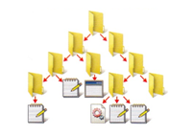

File system attributes
A file system has those attributes:
- Maximum partition size: maximum length of a partition.
- Maximum file size: maximum length of a file.
- Cluster size: it is usually configurable. Cluster size is the minimum space unit that a hard disk can use. If you store a file with less size than a cluster or the last cluster used by a file is not full, that space is wasted1.
  - If you have a big cluster size, you obtain the best performance, but you waste disk space. Nowadays, hard disk are massive, and it is a good idea to have a big cluster size, except for very particular cases.
  - If you have a small cluster size, you will obtain worse performance, but you gain disk space.
📖 Important: when you save a file in the hard disk, the file will be divided into clusters that do not have to be consecutive. For example, a 10 kB file in a hard disk with a 4 kB sector size and with two sectors per cluster, will need 3 clusters (the last one almost empty). Maybe, each one of those clusters are in a different cylinder or, even, in a different platter. So to load or save it you need three (slow) access to hard disk (you lose performance)
In general, internally, to order the files, all the file systems have a table (or something similar) to know where are each one of the parts of the file. This table is as a directory to find the files.
There are a lot of popular file systems (ext3, ext4, NTFS, FAT32, FAT16, HPFS, etc.). Even many Operating Systems can use several of them. But in a hard disk partition, you only can use one of them. Each one has different characteristics: maximum file size, security against failures, maximum number of nested directories, maximum characters in file names, etc.
📖 Important: A partition is a logical division of the hard disk. It is very useful to separate information and to prevent future errors. In fact, you can format a partition without affecting the rest of the disk.

❕ Attention: format a disk is not to erase it. A format, among other things, organizes from scratch the file system table. Erasing it is a consequence of this organization.

❕ Attention: if your operating system does not recognize a hard disk file system, it can not save or read information on it.

Absolute and relative paths
When we go through a file system, and we want to refer to a directory or a file, we can use two kinds of paths: relative and absolute.
- Absolute path: it includes all the path starting from the root.
- Relative path: it depends on what position are we.
  - Special symbols in relative paths:
    - . → 1 single point reference to current directory.
    - .. → 2 points reference to parent directory
- Sample:
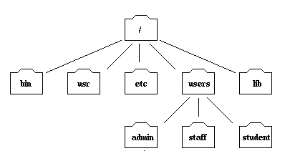
- An absolute path to access to admin is “/users/admin”.
- If you are in /bin, a relative path to access to admin is ../users/admin
- If you are in /, a relative path to access to admin is users/admin or ./users/admin.

Most popular file systems features

 | FAT16 | FAT32 | NTFS | ext4
Operating system | MS-DOS 6.22, Windows 9X | Windows 9X, Windows Server, Windows XP/7/10/11 | Windows Server, Windows XP/7/10 | Linux
Max file size | 2 GiB | 4 GiB | Limited by volume size | 16 GiB to 16 EiB
Max partition size | 2 GiB | 2 TiB | Limited by volume size | 1 EiB

Additional material
[1] Operating systems tutorial (advance)
http://www.tutorialspoint.com/operating_system/

[2] Solucionador de problemas de planificación de procesoss
http://uhurulabs.com/PlanificadoresCPU/

Bibliography
[1] Operating systems
https://en.wikipedia.org/wiki/Operating_system

[2] Process management
https://en.wikipedia.org/wiki/Process_management

[3] Memory management
https://en.wikipedia.org/wiki/Memory_management

[4] Device management
https://es.wikipedia.org/wiki/Device_Management

[5] File system
https://en.wikipedia.org/wiki/File_system

[6] Comparison of file systems
https://en.wikipedia.org/wiki/Comparison_of_file_systems

